OBSERVATION TASK
Course: Full Stack Web Development | Course Code: 23CM4121
Experiment No.: Observation Task 1 Part B | Student Name: M.Naga Doleswari Aruna Devi
Roll No.: A24126552267 | Date: 30-08-2026

1. TITLE
Explore CSS3 Styling and HTML5 Canvas Graphics

2. AIM
To understand how CSS3 enhances the appearance of web pages and to explore HTML5 graphics using the Canvas element.

3. OBJECTIVE
- To understand the basic syntax and structure of CSS3.
- To apply CSS selectors, colors, fonts, borders, margins and padding.
- To style a webpage using backgrounds, gradients, box shadow, text shadow and rounded corners.
- To implement hover effects for navigation links and buttons.
- To draw basic shapes and text on a webpage using the HTML5 Canvas element.

4. THEORY
CSS3 (Cascading Style Sheets, Level 3) is the latest evolution of the CSS language used to control the presentation and layout of HTML documents. It introduces advanced styling features such as gradients, box shadows, text shadows, rounded corners (border-radius), and hover-based transition effects, allowing developers to design visually appealing web pages without relying on images or scripts.
CSS rules follow the syntax selector { property: value; }. Selectors can target elements by tag name, class (.class), id (#id), or pseudo-classes such as :hover, which applies a style only while the mouse pointer is over an element.
HTML5 introduces the <canvas> element, a rectangular region on the page that can be used to draw graphics, shapes, and text dynamically using JavaScript. The 2D drawing context is obtained using canvas.getContext("2d"), which exposes methods such as fillRect() for rectangles, arc() for circles, moveTo()/lineTo()/stroke() for lines, and fillText() for text.
Together, CSS3 and HTML5 Canvas allow a single webpage to combine styled document content (header, navigation, cards, footer) with custom-drawn graphics, demonstrating both declarative styling and imperative, script-driven rendering.

5. ALGORITHM / PROCEDURE
- Create a new HTML file and set up the basic HTML5 document structure.
- Add a <style> block and define general/reset styles (margin, padding, box-sizing).
- Style the body with a font family and a linear gradient background.
- Create a header section with a subtitle and apply background color, text color and text-shadow.
- Create a navigation bar with links; style the links and add a :hover effect with a color change.
- Insert a <canvas> element inside a div and give it a border and background.
- Using JavaScript, get the 2D drawing context of the canvas.
- Draw a filled rectangle using fillRect().
- Draw a filled circle using beginPath(), arc() and fill().
- Draw a straight line using moveTo(), lineTo() and stroke().
- Display the student's name on the canvas using fillText().
- Create three content cards with borders, border-radius, box-shadow and a button in each.
- Add a :hover effect on the buttons to change their background color.
- Create a footer with background color and centered text.
- Open the HTML file in a browser and verify the layout, styling and canvas drawing.
- Test hover effects on navigation links and buttons, and verify canvas shapes render correctly.

6. PROGRAM
index.html
<!DOCTYPE html>
<html lang="en">
<head>
<meta charset="UTF-8">
<meta name="viewport" content="width=device-width, initial-scale=1.0">
<title>My Styled Webpage</title>
<style>
* {
margin:0;
padding:0;
box-sizing:border-box;
}
body {
font-family:Arial, sans-serif;
background:linear-gradient(to right,#74ebd5,#ACB6E5);
}
/* Header */
header {
background:#003366;
color:white;
text-align:center;
padding:20px;
text-shadow:2px 2px 5px black;
}
/* Navigation */
nav {
background:#222;
padding:15px;
text-align:center;
}
nav a {
color:white;
text-decoration:none;
margin:20px;
font-size:18px;
padding:10px;
border-radius:5px;
}
nav a:hover {
background:orange;
color:black;
}
/* Canvas */
.canvas-box {
text-align:center;
margin:30px;
}
canvas {
border:2px solid black;
background:white;
}
/* Cards */
.container {
display:flex;
justify-content:space-evenly;
margin:40px;
}
.card {
width:280px;
background:white;
border:2px solid gray;
border-radius:20px;
padding:20px;
box-shadow:5px 5px 15px gray;
text-align:center;
}
.card h2 {
font-family:Georgia; color:darkblue;
}
.card p {
margin:15px 0;
font-size:17px;
}
button {
background:royalblue;
color:white;
padding:10px 20px;
border:none;
border-radius:8px;
cursor:pointer;
}
button:hover {
background:green;
}
/* Footer */
footer {
background:#003366;
color:white;
text-align:center;
padding:15px;
margin-top:30px;
}
</style>
</head>
<body>
<header>
<h1>My Styled Webpage</h1>
<p>HTML5 Graphics & CSS3 Web Styling</p>
</header>
<nav>
<a href="#">Home</a>
<a href="#">About</a>
<a href="#">Courses</a>
<a href="#">Contact</a>
</nav>
<div class="canvas-box">
<h2>HTML5 Canvas Demo</h2>
<canvas id="myCanvas" width="500" height="250"></canvas>
</div>
<div class="container">
<div class="card">
<h2>HTML5</h2>
<p>HTML provides the basic structure of webpages.</p>
<button>Learn More</button>
</div>
<div class="card">
<h2>CSS3</h2>
<p>CSS makes webpages attractive using colors, fonts and layouts.</p>
<button>Learn More</button>
</div>
<div class="card">
<h2>JavaScript</h2>
<p>JavaScript adds interactivity and dynamic behaviour.</p>
<button>Learn More</button>
</div>
</div>
<footer>
<h3>© 2026 My Styled Webpage</h3>
</footer>
<script>
var canvas=document.getElementById("myCanvas");
var ctx=canvas.getContext("2d");
/* Rectangle */
ctx.fillStyle="blue";
ctx.fillRect(20,20,120,70);
/* Circle */
ctx.beginPath();
ctx.arc(220,55,35,0,2*Math.PI);ctx.fillStyle="red";
ctx.fill();
/* Line */
ctx.beginPath();
ctx.moveTo(300,20);
ctx.lineTo(450,100);
ctx.strokeStyle="green";
ctx.lineWidth=3;
ctx.stroke();
/* Name */
ctx.font="28px Arial";
ctx.fillStyle="purple";
ctx.fillText("Aruna Devi",150,180);
</script>
</body>
</html>

7. CODE EXPLANATION
Code | Explanation
linear-gradient() | Creates a smooth transition between two colors, used as the page background.
text-shadow | Adds a shadow behind text; used on the header title and subtitle for depth.
:hover | Pseudo-class that applies styles only while the mouse pointer is over the element (nav links, buttons).
border-radius | Rounds the corners of an element, used on cards and buttons.
box-shadow | Adds a drop shadow around an element, used on the content cards.
getContext("2d") | Returns the 2D rendering context of the canvas, used to draw shapes and text.
fillRect() | Draws a filled rectangle at a given position and size on the canvas.
arc() | Draws a circular arc (used with fill() to draw a filled circle).
moveTo() / lineTo() / stroke() | Defines and draws a straight line path on the canvas.
fillText() | Renders text (the student's name) at a specified position on the canvas.

8. TEST CASES AND EXECUTION DATA
Each styling feature and canvas element was verified individually in the browser.
Test Case | Feature Tested | Expected Result | Actual Result | Status
TC-01 | Page load | Header, nav, canvas, cards and footer render correctly | Rendered correctly | Pass
TC-02 | Gradient background | Body shows a smooth color gradient | Gradient displayed correctly | Pass
TC-03 | Canvas shapes | Rectangle, circle, line and name text appear on canvas | All shapes and text displayed | Pass
TC-04 | Nav link hover | Link background turns orange with text color change on hover | Hover effect worked | Pass
TC-05 | Button hover | Button background changes to green on hover | Hover effect worked | Pass
TC-06 | Card styling | Cards show border-radius and box-shadow | Displayed correctly | Pass

9. OUTPUT
Output 1: Full Page View
The page displays a styled header with a shadowed title and subtitle, a navigation bar with hover-based color changes, the HTML5 Canvas drawing (a blue rectangle, a red circle, a green diagonal line and the student's name in purple text), three styled cards with rounded corners, shadows and buttons, and a footer, all rendered correctly in the browser.
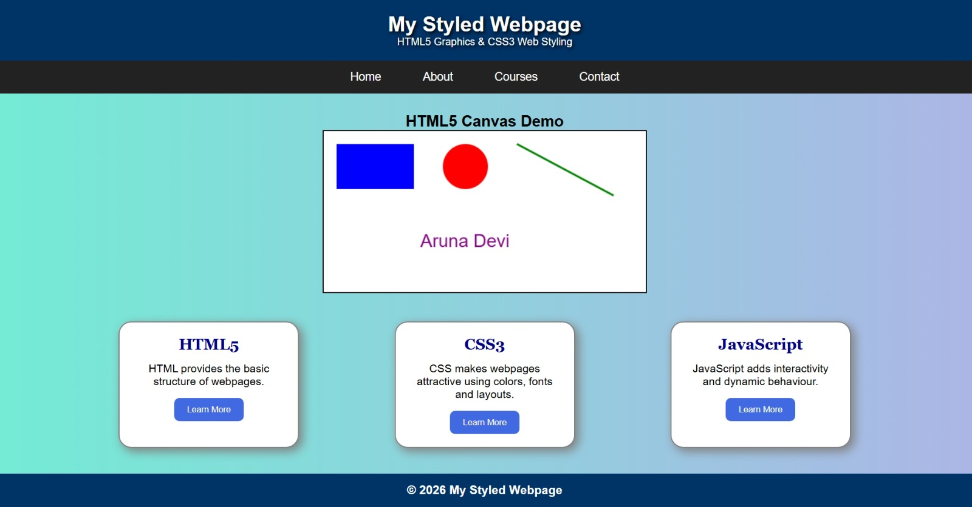

10. RESULT
Thus, a webpage titled "My Styled Webpage" was successfully designed using CSS3 styling techniques (gradients, shadows, borders, rounded corners and hover effects) and HTML5 Canvas graphics (rectangle, circle, line and text). All components were verified in the browser and the required visual effects were achieved as expected.

